React Assignments

Code:-

App.js

<div>

<h1>Project Showcase</h1>

<p>Your gateway to amazing design projects.</p>

</div>

Output:-

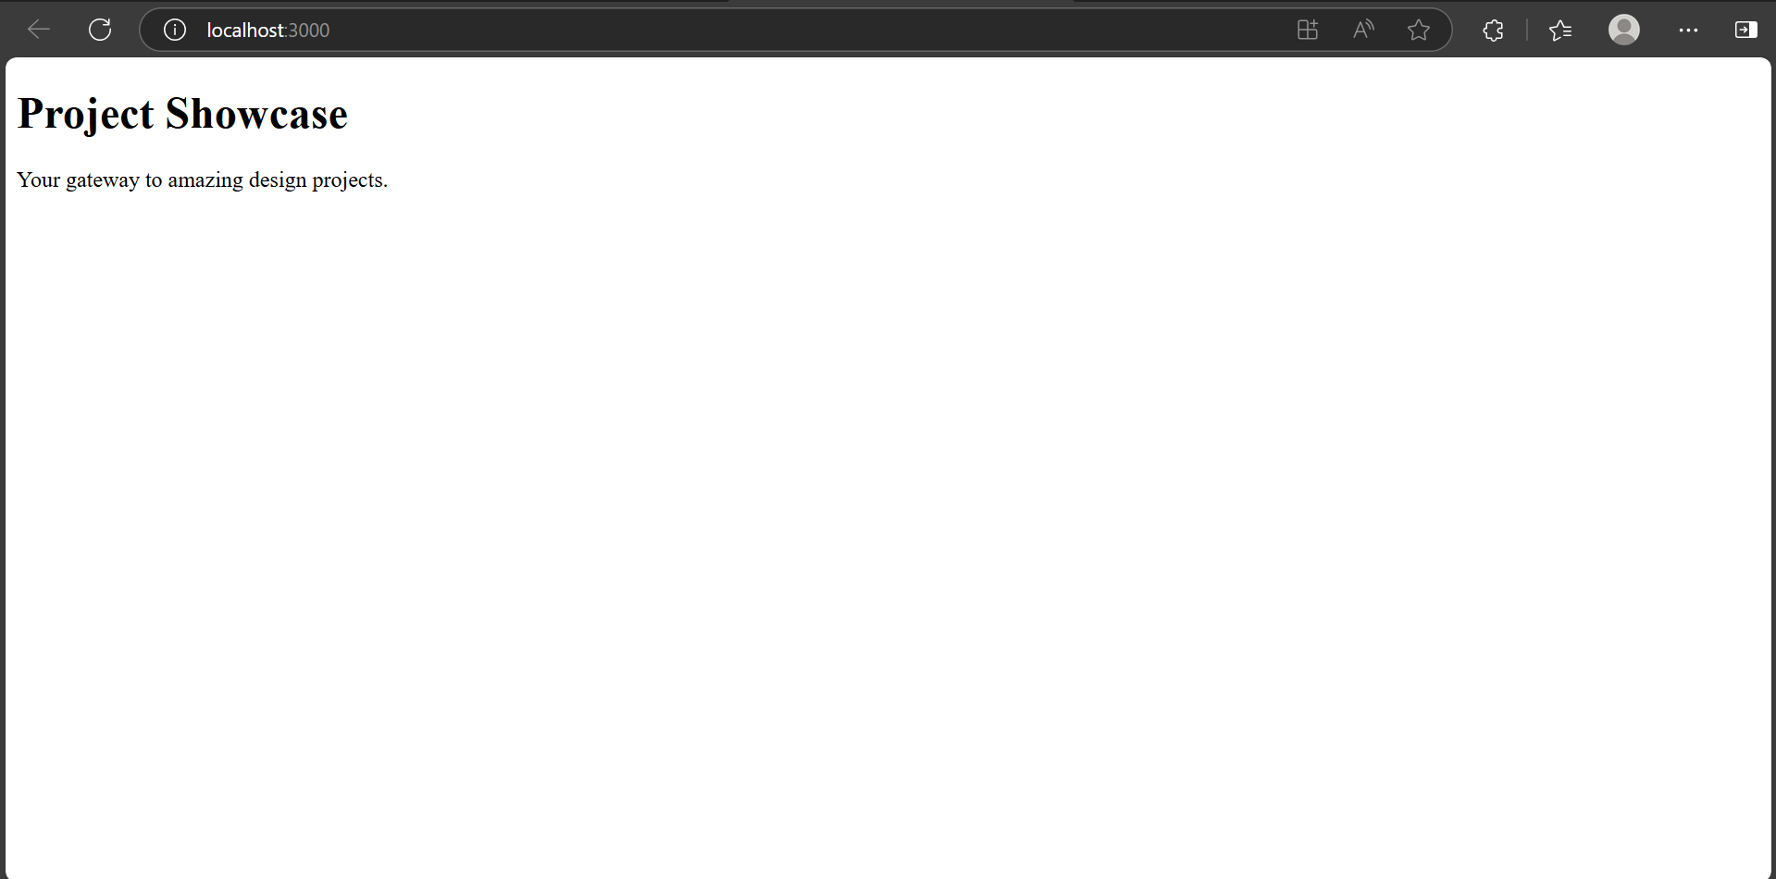

Counter.jsx

import { useState } from "react";

export default function Counter(){

    const[like,setLike]=useState(0);

    return(

        <div>

            <p>Total Likes: {like}</p>

            <button onClick={()=>setLike(like+1)}>Like</button>

        </div>

    );

}

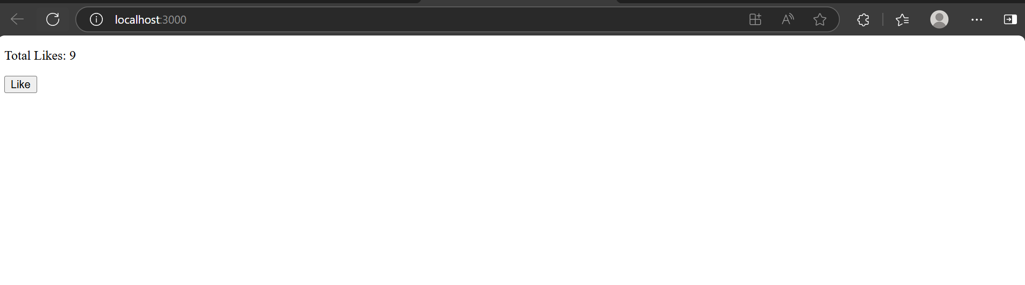

ControlledComponents.jsx

import { use, useState } from "react";

export default function ControlledComponents(){

    const[email,setEmail]=useState("");

    return(

        <div>

            <label>Email: </label>

            <input type="text" value={email} onChange={(e)=>setEmail(e.target.value)}/>

        </div>

    );

}

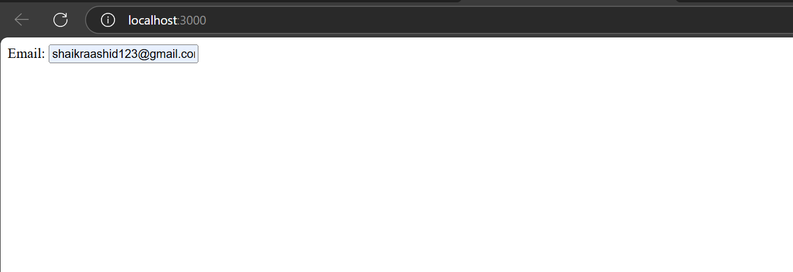

Code

import { useState } from "react";

export default function ConditionalRendering(){

    const[day,setDay]=useState(true);

    return(

        <div>

            <button onClick={()=>setDay(!day)}>Switch to {day ? 'Night':'Day'}</button>

            <p>Current Mode: {day ? 'Day' : 'Night'}</p>

        </div>

    );

}

App.js

export default function App() {

  return (

 <div>

     <Propstry name="Abdul Raashid"/>

  <Propstry name="Abdul Muyeed"/>

    <Propstry name="Shaik Naveed"/>

 </div>

Propstry.jsx

export default function Propstry({name}){

    return(

        <div>

            Team Members: {name}

        </div>

    );

}

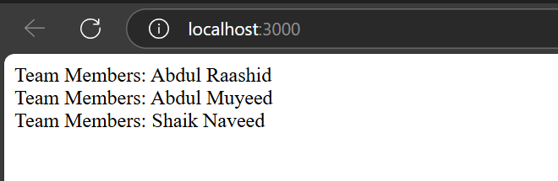

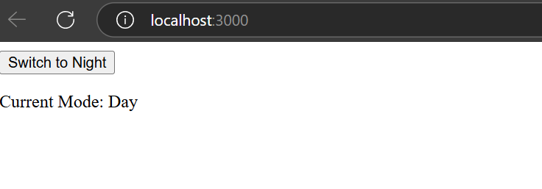

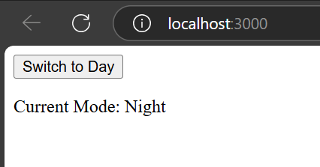

DynamicRendering.jsx

export default function DynamicRendering(){  
const[items,setItems]=useState(['Bread','Milk','Eggs']);  
return(  
<div>  
{items.map((item,index)=>(  
<li key={index}>  
{item}  
</li>  
))}

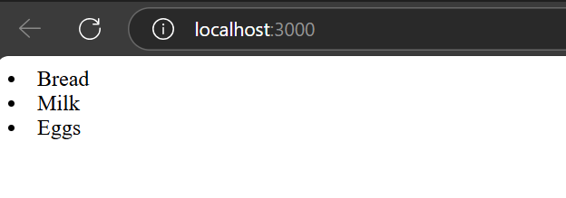

Code

<h1 style={{ color: 'teal', textAlign: 'center' }}>Join Our Newsletter</h1>

.ctaButton {

background-color: orange;

color: white;

padding: 10px 20px;

border: none;

}

import styles from './Button.module.css';

<button className={styles.ctaButton}>Subscribe</button>

import { useEffect, useState } from "react";

export default function UseEffect(){

    const[data,setData]=useState([]);

    const[error,setError]=useState([]);

    useEffect(()=>{

        fetch('https://jsonplaceholder.typicode.com/posts')

        .then((res)=>res.json())

        .then((datas)=>setData(datas))

        .catch(console.error(error))

    },[])

    return(

        <div>

            <ul>

                {data.map((d,index)=>(

                    <li key={index}>

                        {d.title}

                        {d.id}

                    </li>

                ))}

            </ul>

        </div>

    );

}

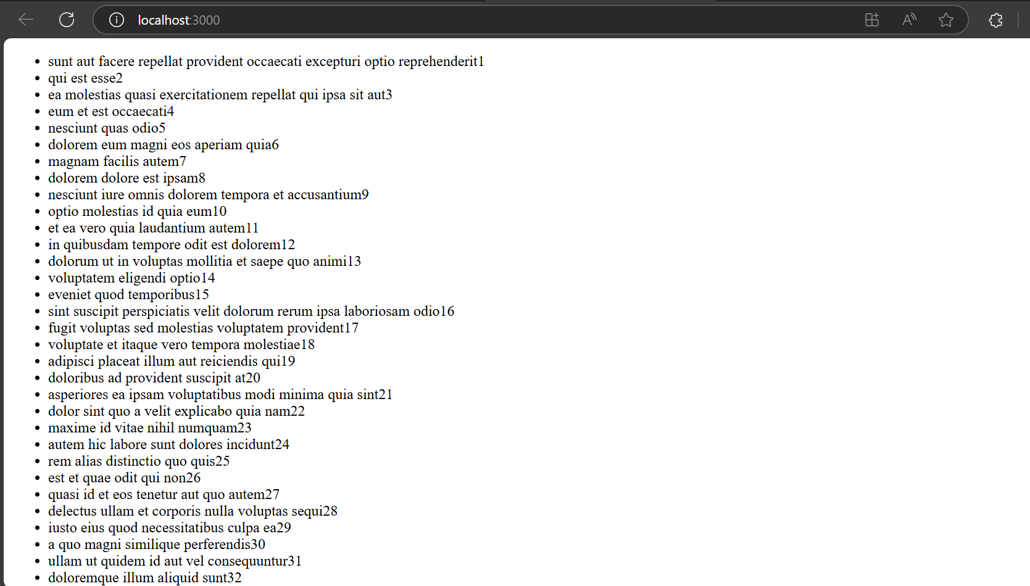

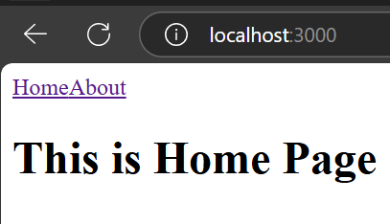

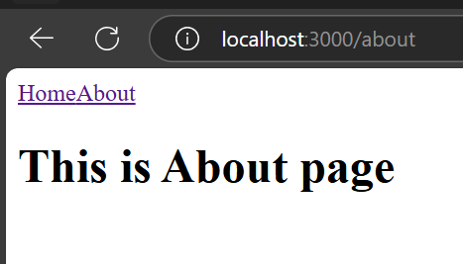

useFetch.js:

import { useState, useEffect } from 'react';

export function useFetch(url) {

const [data, setData] = useState(null);

const [loading, setLoading] = useState(true);

useEffect(() => {

fetch(url)

.then(response => response.json())

.then(json => {

setData(json);

setLoading(false);

});

}, [url]);

return { data, loading };

}

App.js:

const { data, loading } = useFetch('https://jsonplaceholder.typicode.com/users');

if (loading) return <p>Loading...</p>;

return (

<ul>

{data.map(user => (

<li key={user.id}>{user.name}</li>

))}

</ul>

);